# GIT HANDSON-3

**Gitlab:** [**https://gitlab.com/syamprasad-111-group/gitdemo**](https://gitlab.com/syamprasad-111-group/gitdemo)

**1. Branching and Merging in Git**  
Branching allows developers to work separately on features or fixes without affecting the main code (usually the master branch).  
Merging combines changes from one branch (like a feature) into the main branch.

**2. Creating a Branch in GitLab**

* Login and open your repo.
* Go to the Branches section.
* Click New Branch.
* Enter a name and base branch.
* Click Create Branch.

**3. Creating a Merge Request in GitLab**  
A merge request lets you combine your changes into another branch. Steps:

* Push your changes. GitLab prompts for a merge request. Or go to Merge Requests → New Merge Request.
* Select source and target branches.
* Add a title, description, and (optionally) reviewers.
* Click Create Merge Request.

**LAB :  
  
PART 1: Branching in Git**

**Step 1:** Create a new branch called GitNewBranch

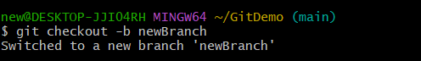

**Step 2:** List all branches (local and remote)

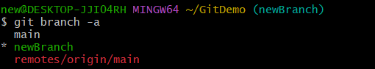

**Step 3:** Create a new file in the branch



**Step 4:** Stage and commit the file

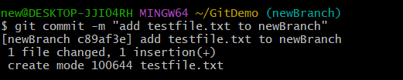

**Step 5:** Check status

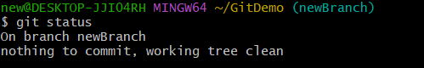

**PART 2: Merging in Git**

**Step 6:** Switch back to master (or main) branch

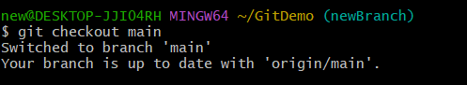

**Step 7:** See differences between master and GitNewBranch (CLI)

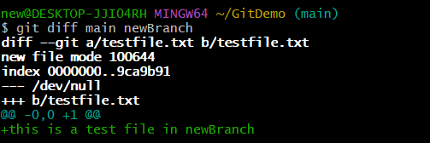

**Step 8:** See visual diff using P4Merge

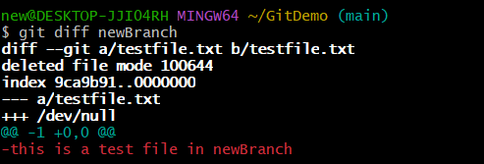

**Step 9:** Merge branch to main

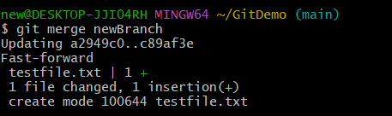  
  
**Step 10:** View log graphically

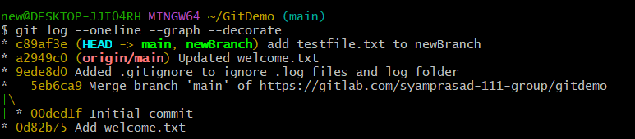

**Step 11:** Delete merged branch



**Step 12 :** Push your changes to GitHub

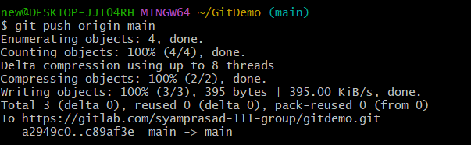

**Final “GitDemo” Repository:**

